Hi Immanuel, here's an update on Gen2X features on FX/ATR
FX7500 and 9600 supports all 5 features: protected mode, fastID, TagFocus, Tag Quieting, performance features
ATR supports fastID, TagFocus, Tag Quieting, performance features;
Protected mode is not supported
In ATR Portal directionality mode, gen2X features cannot be applied

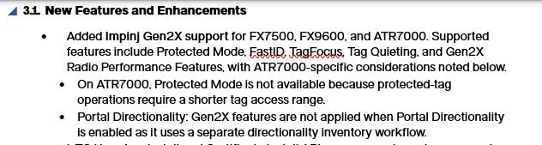

Hi
Chandrashekar, Kavitha, I wanted to confirm whether this behavior should be documented as part of the Gen2X Reference Guide.

Based on the recent clarification from the engineering team, I understand that FastID, TagFocus, Tag Quieting, and Protected Mode are Impinj Gen2X features configured through set_impinjGen2X, whereas the Gen2X Radio Performance Feature is configured separately using inventoryProtocol.mode (GEN2, GEN2X, HYBRID) through the set_mode API.
Should we include a section in the Impinj Gen2X documentation describing the set_mode inventory protocol options (GEN2, GEN2X, and HYBRID) and their behavior, or should the guide remain focused only on the Impinj Gen2X feature APIs (FastID, TagFocus, Tag Quieting, and Protected Mode)?
During testing, I observed that:
- GEN2 inventories both Gen2 and Gen2X tags.
- GEN2X inventories only Gen2X-capable tags.
- HYBRID inventories both Gen2 and Gen2X tags using their respective protocols.
Hi Immanuel, Radio performance features are also one of the main features we’ve released and told people about, if there’s currently no guide how to enable them, we need to incorporate For both starfish and sand dollar Otherwise they’re going to reach out to us anyway if they cannot find the steps to use that feature
Supported Readers
Impinj Gen2X is supported on FXR Fixed Readers, FX9600, FX7500 ASIC, FX7500 legacy, and ATR7000. FastID, TagFocus, and Tag Quieting are available across these readers. Protected Mode and Gen2X Radio Performance Features have the following reader-specific considerations:
ATR7000
Protected Mode: Not available because protected-tag operations require a shorter tag access range than the typical ATR7000 operating distance.
Gen2X Radio Performance Features: Not available due to differences in the reader’s radio architecture and inventory processing.
Portal Directionality: Gen2X features are not applied when Portal Directionality is enabled because it uses a separate directionality inventory workflow.
Legacy FX7500
Protected Mode and Gen2X Radio Performance Features are not available on legacy hardware.

Overview
This reference explains how to configure and use the following Gen2X capabilities through MQTT and REST APIs:
Protected Mode: Protect individual tags using authenticated access so they are not visible to unauthorized readers.
FastID: Return the EPC and TID as part of the same inventory response.
TagFocus: Reduce repeated reporting of previously inventoried tags so the reader can prioritize new tags.
Tag Quieting: Quiet selected tags based on EPC ID through reader-level configuration.
Gen2X Radio Performance Features: Configure supported Gen2X radio-level features (Gen2, Gen2X or Hybrid) to optimize tag inventory performance.

on ATR7000, Gen2X Radio Performance Features is still in testing and could be supported/not supported

we have to wait to hear from the team

I think we can go ahead with FXR rest and mqtt docs for publish, for Gen2X reference guide, let us wait until the testing is complete

maybe this is not aligning straight

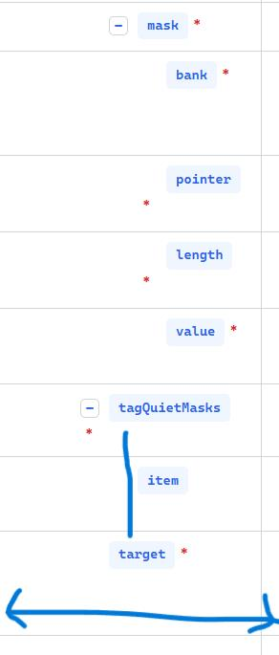

if u expand the column that might fix the issue

in rest schema, are these needed? if not remove it
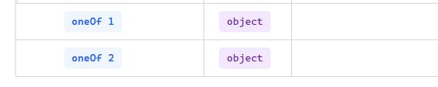

Supported Readers
Impinj Gen2X is supported on FXR Fixed Readers, FX9600, FX7500 ASIC, FX7500 legacy, and ATR7000. FastID, TagFocus, and Tag Quieting are available across these readers. Protected Mode and Gen2X Radio Performance Features have the following reader-specific considerations:
ATR7000
Protected Mode: Not available because protected-tag operations require a shorter tag access range than the typical ATR7000 operating distance.
Gen2X Radio Performance Features: Not available due to differences in the reader’s radio architecture and inventory processing.
Portal Directionality: Gen2X features are not applied when Portal Directionality is enabled because it uses a separate directionality inventory workflow.
Legacy FX7500
Protected Mode and Gen2X Radio Performance Features are not available on legacy hardware.

Overview
This reference explains how to configure and use the following Gen2X capabilities through MQTT and REST APIs:
Protected Mode: Protect individual tags using authenticated access so they are not visible to unauthorized readers.
FastID: Return the EPC and TID as part of the same inventory response.
TagFocus: Reduce repeated reporting of previously inventoried tags so the reader can prioritize new tags.
Tag Quieting: Quiet selected tags based on EPC ID through reader-level configuration.
Gen2X Radio Performance Features: Configure supported Gen2X radio-level features (Gen2, Gen2X or Hybrid) to optimize tag inventory performance.

on ATR7000, Gen2X Radio Performance Features is still in testing and could be supported/not supported

we have to wait to hear from the team

